I Love to learn Portsmouth/Havant/fareham
An Alternative Provision
Specialists in Maths & English Tuition



www.ilovetolearn.co.uk

3 Beacon House, Cumberland Business Centre,  Southsea, PO5 1DS | Phone 023 93 968626  tutors@ilovetolearn.co.uk | Specialists in Maths & English Tuition

The number of children not being able to access education has increased dramatically over the last few years. The tutoring programme, which was introduced by the government, has gone some way to help the situation for children and for schools, but it has not been the solution that many had hoped for. Here at I Love to Learn, we can offer you a bespoke service to help deliver Maths and English tuition to students who, for any reason, may not be able to attend school. Our highly qualified and trained tutors provide individual or small group teaching in a caring and supportive environment. We can cater to small groups or individuals, depending on the situation. Our customized resources will be used, and progress will be demonstrated through before and after evidence. We are Ofsted registered and successfully working with a Hampshire school. We look forward to helping you too.

Proposal document

I Love to Learn Professional Tuition
1. What We Offer
2. Our Tutoring Programmes-
One-to-one
Small Group Settings
Effective Feedback
Homework
ICT
Assessment
3. Delivery of Maths & English Programmes
Re-assessment and Reporting
4. Programme Cost
Fees

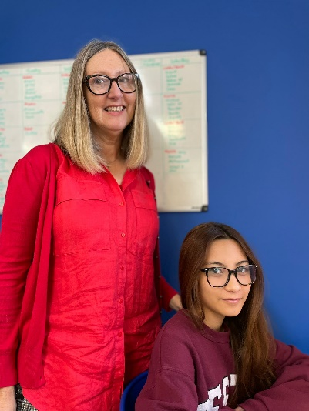

Are you looking for a solution for students who are not in school and find it difficult to engage with traditional classroom settings?
Do you know some of your students have gaps or who need special attention?
Do you have Pupil Premium or School Refusers who need support?

- What We Offer
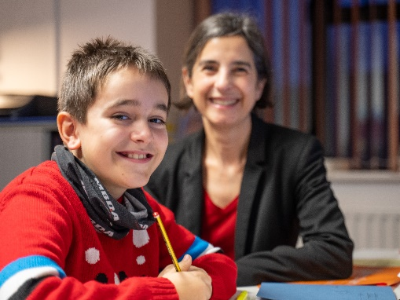
A free initial assessment for every child.
A dedicated, safe and OFSTED registered tuition centre.
Experienced, caring and qualified teachers with a high level of professionalism.
An individual plan made for each child adjusted weekly.
Differentiated ways to learn through computer activities, structured worksheets, workbooks and audio resources.
Regular, professional feedback and re-assessment of progress

Our Tutors
Our tutors hold full qualifications and are experienced classroom teachers with DBS and QTS certification. Our centre currently serves over 200 children weekly, with ten tutors on staff helping local school children from Year 2 to Year 11.

Working with Schools
We are currently working with students not in school with one-to-one tuition in our Fareham and Havant Centres.
In 2020 we delivered small group maths GCSE tuition for Havant Academy at the school for Year 11 students.
We have worked with several schools including Ark Dickens Primary (Portsmouth), Priory School (Southsea) to delivery booster tuition sessions in our Portsmouth Centre.
We have supported LAC through Action for Children and other fostering organisations with one-to-one sessions to support their re-entry into full time education.
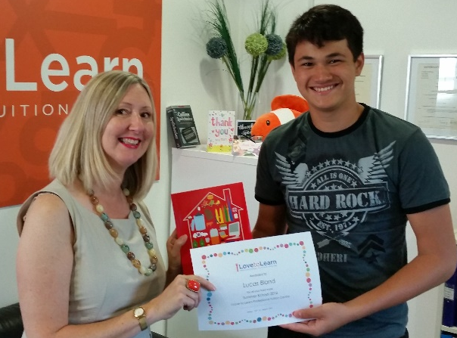

- Our Tutoring Programmes

We focus on either English or maths to boost pupil’s achievement and support them to make more than expected progress.
We provide an individual initial assessment which will baseline a student’s current level of attainment.
We then plan a bespoke programme which is delivered by our qualified, experienced teachers using our unique resources.
Additionally, we track the progress that pupils make on our plans and record progress.
We aim to boost students’ skills and confidence to help them return to full time education. This is done in a sensitive and supportive manner.
One-to-one Sessions in a Small Group Setting
If appropriate, some tutoring takes place in small groups of 2 or 3 and is an 60 or 120-minute sessions. We find that individual tuition delivered in small groups reduces the pressure on students, and is more motivating, as they are working alongside others. We would emphasise that it is not small group work, as each child does different work suited to their level of ability.
One-to-one Sessions
In some cases, small groups are not small enough, and one-to-one sessions are necessary. These are kept to 60 minutes as they can be more intense.
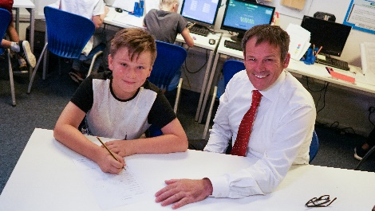
Effective feedback-This is delivered by the tutor monitoring and marking the child’s progress throughout the session. Our computer tuition resource gives instant feedback to tutors and children.
Homework-we set paper homework that is often a repeat of work that has already been done in their session. We use this to check that children can complete it independently and to analyse areas of weakness that need to be reinforced. This also links with parts of the programme carried out in the centre and is therefore progressive.
ICT-All the students use ICT in the lessons with the sessions being planned and delivered with our numeracy & literacy programme. This includes a combination of written and computer activities, but all marking and progress is recorded. Correct and incorrect answers can be tracked. Many of the activities are first written and then reinforced with a computer activity.
Base Line Assessment: we test each child’s reading age, spelling age and writing/maths skills depending on the subject/subjects requested. We use this to plan where each child starts in our tutoring programme. The work is tailor made to target the child’s specific weaknesses. With greater success the child’s confidence and enjoyment returns, and they re-engage with the learning process.
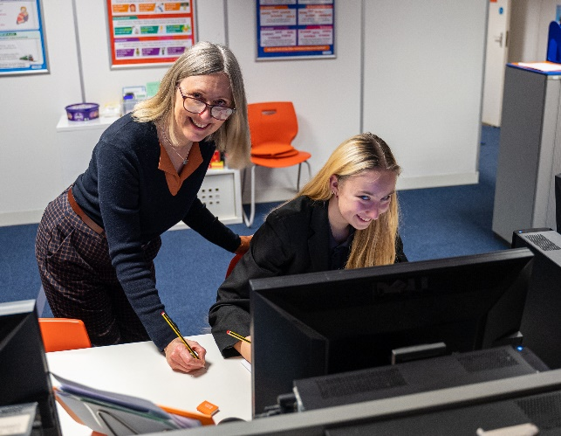

- Delivery of Maths & English Programmes
Numeracy
- 60-80 minute session
- Warm up: Tables
- Core Maths 1 to 9
- Core Skill Builder
- Target KS3/4 Maths Area 1
- Target KS3/4 Maths Area 2
- Games-arithmetic
Students are given one sheet of core maths homework at the end of the session.
Our focus is on improving fluency as well as accuracy with number and then higher-level skills. With the basic skills secure we can then focus on other KS3/4 topics. We set a mixture of at least six activities lasting from 5-15 minutes each.

Literacy
- 60–80-minute session
- Warm up: reading or vocabulary
- Core Skill English Grammar/Punctuation
- Core Skill Builder Comprehension
- Target Grammar
- Target Writing/Planning/ Proof Reading/Re-Writing
- Games-Spelling
Students are given one sheet of core mixed homework at the end of the session.
We aim to build skills across the range of literacy targets depending on the areas of weakness displayed by the student. With the basic skills secure we can then focus on KS3/4 written expression and writing for purpose.

Re-Assessment and Reporting
A base line score is recorded at the beginning of the pilot.
Individual Report-work done and progress is recorded on our paper plans each lesson.
We re-assess at regular intervals and provide a report to show progress. This can be sent hard copy or by email.

- Programme Cost
Baseline assessments - free

a) After School Sessions £46 for each 80 min lesson
b) Daytime sessions with 2/3 students £37 per student per 60 min session

c) One-to-one £69 per hour

Conclusion:
We are committed to providing the best possible service in whatever way possible. We aim to boost students’ confidence and skills to support their return to mainstream education if possible. If you think we would be a good fit for your needs, please do not hesitate to get in touch.
Looking forward to hearing from you!

Why not email us now to set up an initial conversation:
Tutors@ilovetolearn.co.uk
Ilovetolearn.co.uk

